TASK-6 JENKINS UPSTREAM AND DOWNSTREAM PROJECTS TRIGGERED BY CRON JOB TIMER.

CREATE 3 PROJECTS NAMED DEV,TEST,PROD.

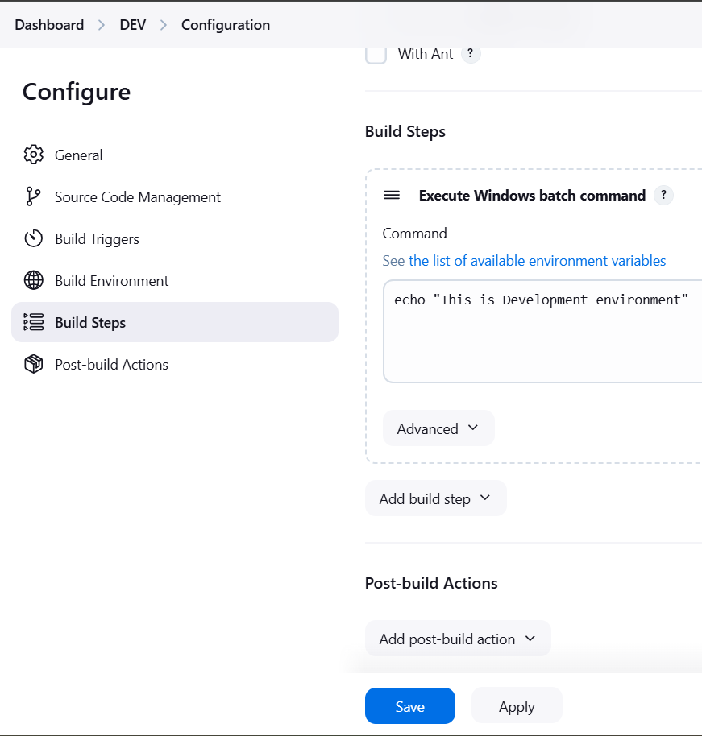

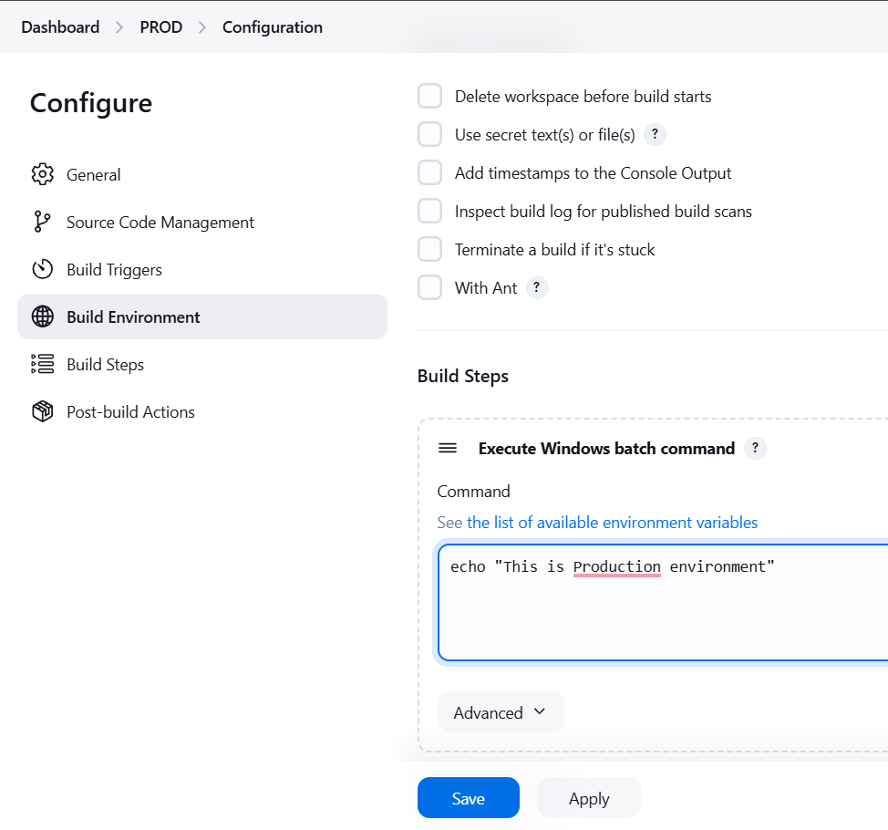

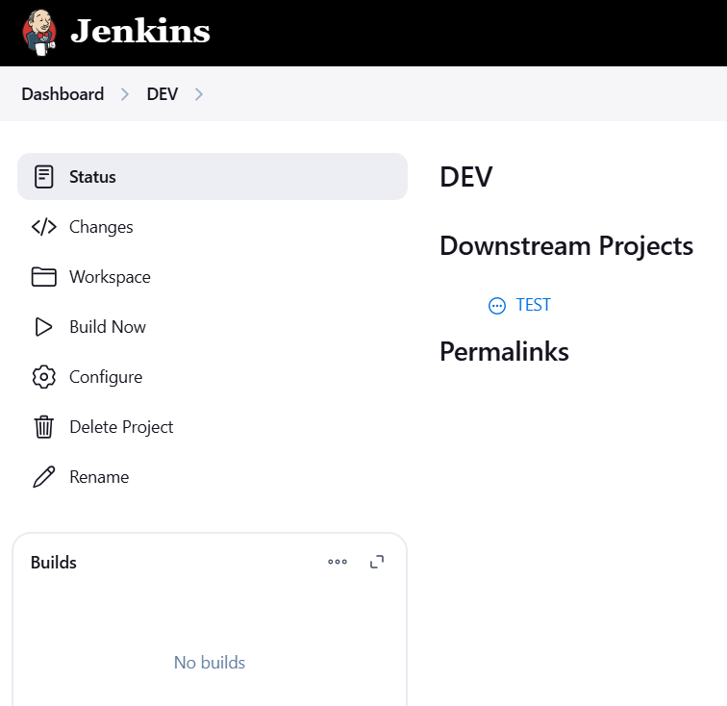

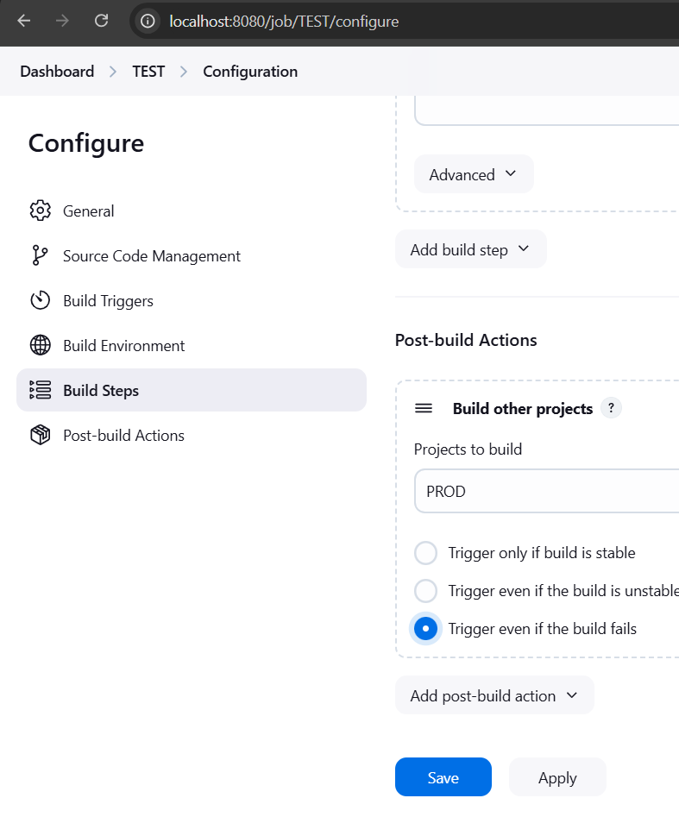

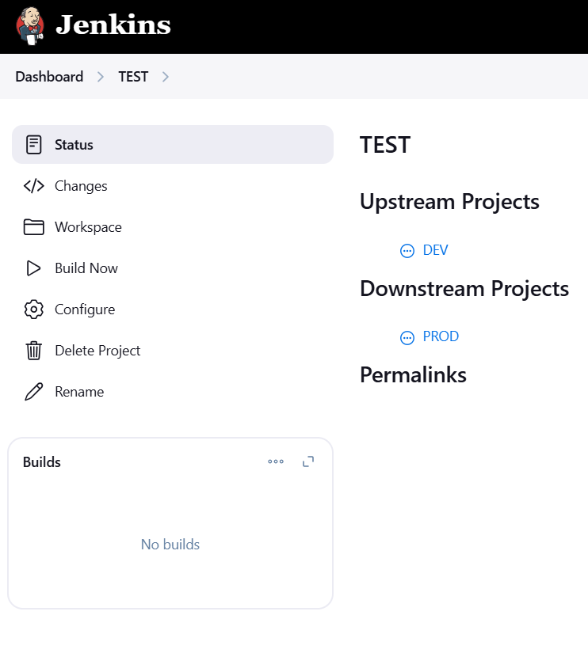

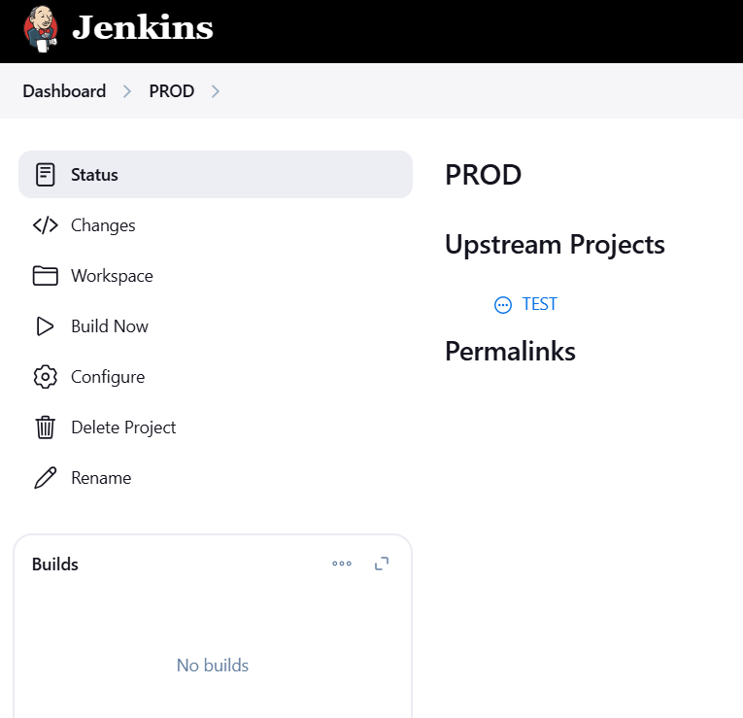

DEV BUILD WAS TRIGGERED PERIODICALLY

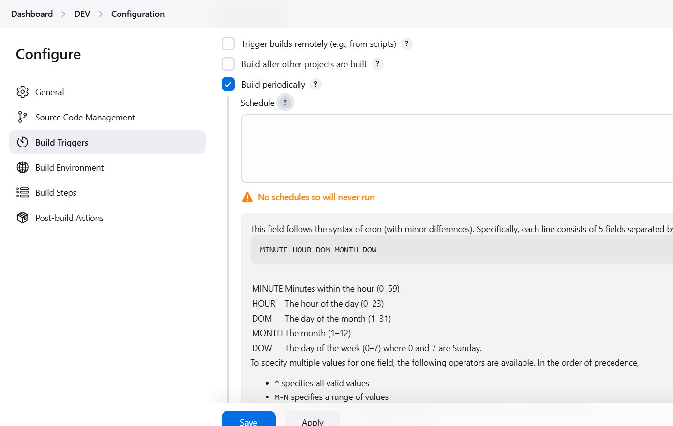

BUILD TRIGGERED BY CRON JOB

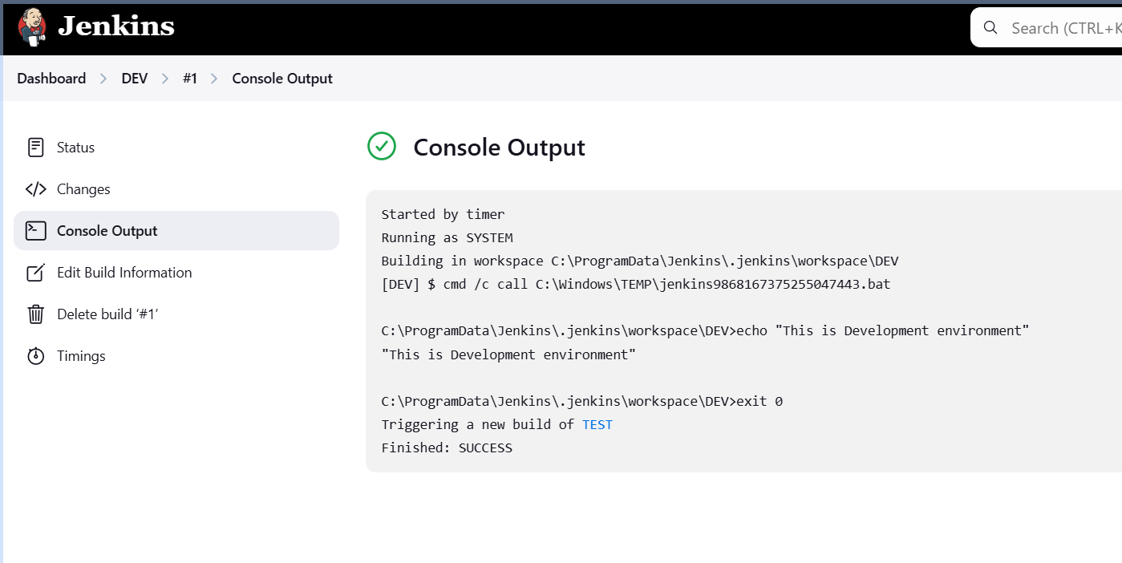

BUILD STARTED BY UPSTREAM PROJECT

